Outdoor Youth Leadership Program
“World Class Training by World Class Guides”

A Skills and Leadership Intensive Program
Date: June 14th – 20th 2019
Age: 14-18 years old Name:_________________________________
Location: Crested Butte, Colorado Age:___________

Application
Experience: Please mark where you feel you fit on the scale below, 1 is no experience, 10 means extensive experience. Then provide a brief description of your experience in that field.

Water/Rafting Experience Soloed the Grand Canyon
Can’t swim in an inner tube
1 2 3 4 5 6 7 8 9 10
__________________________________________________________________________________________________________________________________________________________________________________________________________________________________________
______________________________________________________________________________

Rock Climbing
Steep stairs make me nervous Free climbed El Capitan
1 2 3 4 5 6 7 8 9 10
__________________________________________________________________________________________________________________________________________________________________________________________________________________________________________
______________________________________________________________________________

Mountaineering
I’m from Kansas, mountain what? Rainier is a bunny slope
1 2 3 4 5 6 7 8 9 10
__________________________________________________________________________________________________________________________________________________________________________________________________________________________________________
______________________________________________________________________________
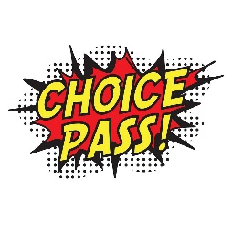

Please take the time to answer the following questions thoughtfully and honestly.

- What are 3 values you possess that will make you an asset to the team?
________________________________________________________________________________________________________________________________________________________________________________________________________________________________________________________________________________________________________________________

Tell us about a time you were in a leadership role. What did you learn from the experience?
________________________________________________________________________________________________________________________________________________________________________________________________________________________________________________________________________________________________________________________

Who is a role model in your life? What qualities do they have that you respect?
________________________________________________________________________________________________________________________________________________________________________________________________________________________________________________________________________________________________________________________

What concerns do you have about joining this trip?
________________________________________________________________________________________________________________________________________________________________________________________________________________________________________________________________________________________________________________________

This program will challenge you physically and mentally. How do you handle stress and physical discomfort? Please provide an example of how you handled a similar situation and what you learned about yourself.
________________________________________________________________________________________________________________________________________________________________________________________________________________________________________________________________________________________________________________________

What are some of your life goals? How do you think completing this course might help you in accomplishing those goals?
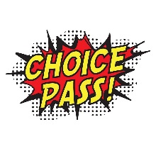
________________________________________________________________________________________________________________________________________________________________________________________________________________________________________________________________________________________________________________________
What does community mean to you? How are you part of the community?
________________________________________________________________________________________________________________________________________________________________________________________________________________________________________________________________________________________________________________________

What is your life motto or philosophy on life?
________________________________________________________________________________________________________________________________________________________________________________________________________________________________________________________________________________________________________________________

How will you bring the skills you learn during this experience back to your school, family, and community?
________________________________________________________________________________________________________________________________________________________________________________________________________________________________________________________________________________________________________________________

If you could have any super power, what would it be?
________________________________________________________________________________________________________________________________________________________________________________________________________________________________________________________________________________________________________________________

The mountains are calling, and I must go. – John Muir
